HW1 -Part6 Report

* **mongo> help [5 commands]**

1. show dbs

1. help admin

1. help connect

1. sh.help()

1. exit()

* **mongo> db.help() [5 commands]**

1. db. version()

1. db.getMongo() #get the server connection object

1. db.dropDatabase()

1. db.getCollectionNames()

1. db.hostInfo

* **mongo> db.mycoll.help() [10 commands]**

1. db.mycoll.find().count()

1. db.mycoll.getIndexes()

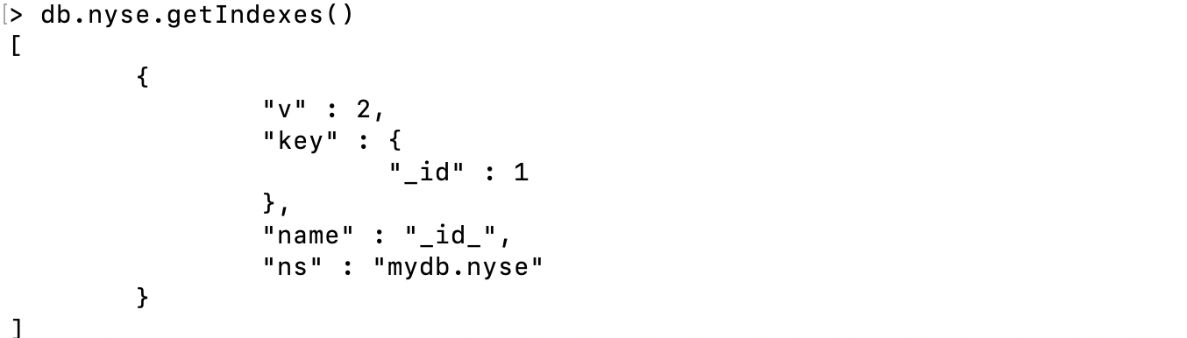

1. db.mycoll.update()

1. db.mycoll.remove()

1. db.mycoll.save()



1. db.mycoll.find(...).limit(n)

1. db.mycoll.insert(obj)

1. db.mycoll.latencyStats()



1. db.mycoll.distinct( key, query, <optional params>)

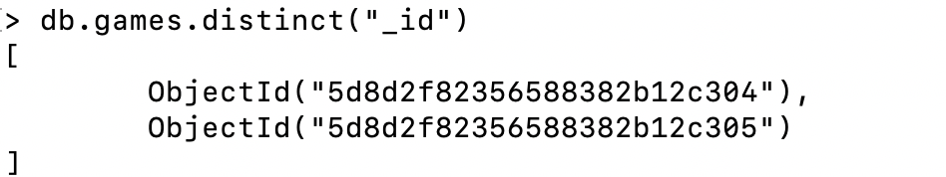

1. db.mycoll.totalSize()

